# 

**News Release**

# 28 December 2016

# Update: Bank of Jamaica Currency Issue

For the week leading up to the Christmas holidays (19 to 23 December 2016), Bank of Jamaica (BOJ) issued currency amounting to *$13.2 billion*, representing an increase of *15.2 per cent* in the currency stock for the week. This was higher than the *$7.2 billion* or *11.4 per cent* increase in stock for the same period in 2015.

The currency issue for the review week contributed to a net increase of *$16.1 billion* or (19.2 *per cent)* in the currency stock for the month-to-23 December 2016, which was broadly in line with the Bank’s projection for an expansion of *19.8 per cent* for the period (see **Figure 1**)

At 23 December 2016, the stock of currency was *$100.1 billion*, representing an increase of *15.9 per cent*, relative to 23 December 2015. When the forecasted change in the consumer price index for December is taken into account, the real growth in currency for the period was *13.8 per cent*, which is much higher than the real growth of *7.6 per cent* for the same period of the previous year. BOJ had projected the currency stock to peak marginally higher on 23 December 2016 at *$100.6 billion,* withsome redemption expected thereafter.

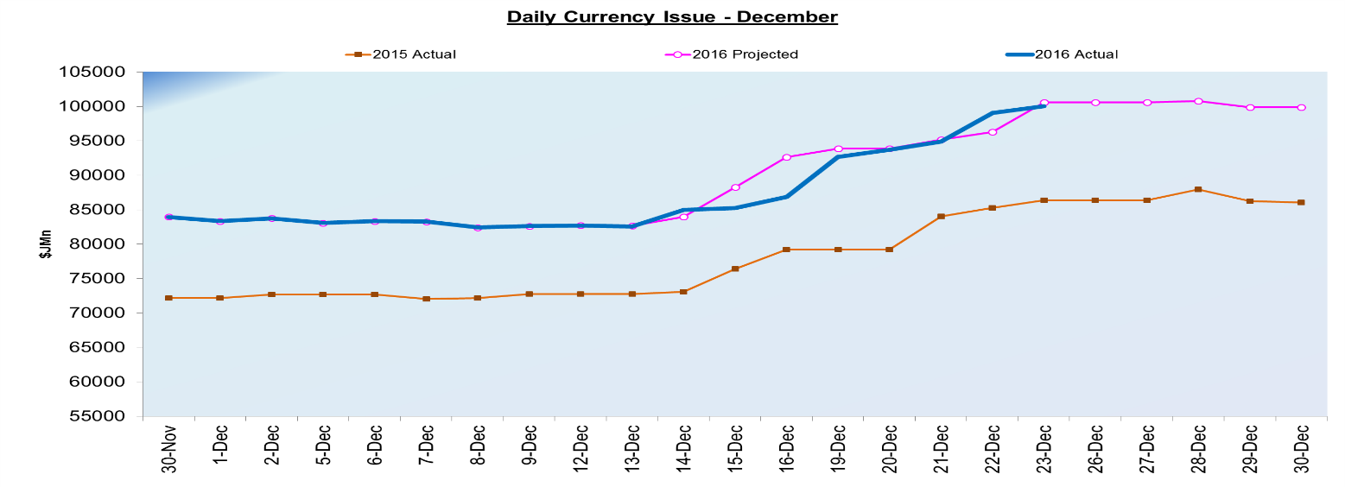**Figure 1**

***Background***

Bank of Jamaica (BOJ) issues and redeems notes and coins daily in order to meet the demand for cash from individuals and businesses. There is normally a stronger demand for currency during the month of December, associated with increased spending over the holiday period. Financial institutions therefore request more currency from BOJ to satisfy this demand.

On 19 December 2016, the BOJ issued a press release indicating that currency stock is projected to increase in December 2016 by *$15.9 billion (19.0 percent)* to *$99.9 billion* at the end of the month*.*

***Glossary:***

* ***Currency Issue****: refers to Jamaican notes and coins in the hands of the public (currency in circulation) in addition to notes and coins held by financial institutions in their vaults (vault cash). BOJ redeems (buys) or issues (sells) notes and coins to financial institutions when institutions have a demand for cash. The difference between currency issued and that which is redeemed during a period of time is referred to as net currency issue.*
* ***Currency Stock or Currency in Circulation****: (see Currency Issue)*
* ***Real Currency Growth****: This is the nominal change in the stock of currency, adjusted for the change in consumer prices over the same period.*
* ***Real Growth****: Reflects annual percentage change in Gross Domestic Product (GDP) using 2007 as the base year.*
* ***Gross Domestic Product (GDP)****: This is the total value of all goods and services produced within an economy over a particular time period –either a year or three months.*